# Snowflake - Dynamic tables

This blog explains the steps to create Dynamic table which is through an automated process it materializes and updates the query results in the table itself i.e. Dynamic table acts as target table itself.

Overview:

1. Creating the source tables
2. Defining the Target dynamic table
3. Inserting and modifying the data in source tables to view the changes in dynamic table.

Step 1:

Once logined to Snowflake, open a new worksheet to execute the queries. Create two source tables(DY_SOURCE, DY_SOURCE1) from where the Dynamic table is going to consume the data.

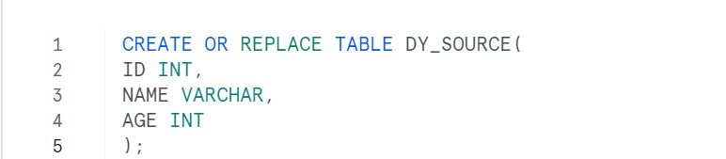

Step 2:

Then, Define a dynamic table with name DY_SINK with TARGET_LAG of 1 minute so it tries to refresh the query results with the given time. Please note that the table refresh time may take longer than TARGET_LAG time based on the query execution time.

Query explanation:

The query is to get only the common data between two source tables by comparing the ID column of both the tables using INNER JOIN.

We are not defining the columns here for the dynamic table because columns will get defined automatically based on query result.

Step 3:

Insert the below data in the source table. Inserting the data in DY_SOURCE table alone which doesn’t make any difference in Dynamic table DY_SINK as expected because as per the defined SQL statement, it is going to look for the common data between both the source tables DY_SOURCE & DY_SOURCE1. Since no new common data is present so it’s not got updated in the dynamic table.



Step 4:

By inserting data in another source table DY_SOURCE1 with the common ‘ID’ column value in DY_SOURCE which makes the dynamic table defined SQL statement with an updated record.



As per the dynamic table defined SQL statement, a new record got inserted in the table.

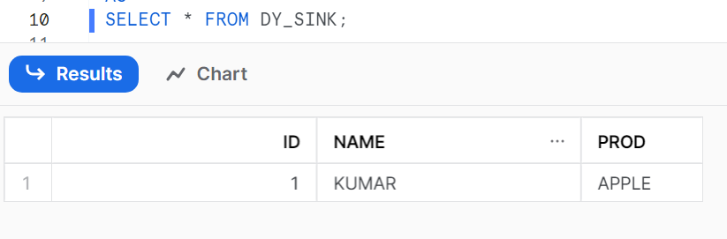

Step 5:

Let’s try updating and deleting the record of same ID: 1 in source table which should get reflected in dynamic table as well.

UPDATING IN SOURCE TABLE:



DELETING FROM SOURCE TABLE:



**SUMMARY:**

As per the query defined for Dynamic table if any differences seen between the dynamic table records and query result records during the refresh lag period then that records will get updated in the table.